TEACHER RESOURCES AND ANSWER KEY
BASIC IELTS
LISTENING SESSION 2

RESOURCE 1

First Text for Reading

We picked Molly up at this woman’s house, but she didn’t look very happy. She cried all the way home in the car and when we arrived back home she refused to move. We were quite worried about her and phoned the woman to explain the situation, but she didn’t seem to care. She told us Molly had always been like this.

Comprehension Questions

Who is Molly?

What was the problem with her? Who was the woman?

Resource 1 Answers

Who is Molly? Actually a dog

What was the problem with her? She was nervous about moving to a new home

Who was the woman? The breeder/original owner of the dog

RESOURCE 2

Context for Second Reading
The speaker is remembering their first day at a new school

Second Text for Reading
When I arrived I was very nervous. There was a lot of noise and more people than I had ever seen before. Mrs Collins was very kind and asked me if I was ok. She introduced me to two girls, Katie and Lola and before long I felt much better. I was having so much fun that at the bell I didn’t want to go home.

Comprehension Questions
How did the speaker feel in the beginning? What was the name of her teacher?
How did the speaker feel at the end of the day?

Resource 2 Answers
How did the speaker feel in the beginning? Nervous
What was the name of her teacher? Mrs Collins (the school context suggests Katie or Lola are other children)
How did the speaker feel at the end of the day? Happy

TEACHER RESOURCES AND ANSWER KEY
BASIC IELTS
LISTENING SESSION 3

Warmer Answer Key

- 30 minutes plus 10 minutes to transfer answers to answer sheet.
- There are 4 sections.
- The first two sections deal with situations set in everyday social settings; the final two sections deal with situations set in educational or training contexts.
- Section 1: 2 speakers Section 2: 1 speaker
Section 3: 2 or more speakers
Section 4: 1 speaker
- Multiple choice / matching / plan, map or diagram labelling / form, note, table or flowchart summary completion / sentence completion / short answer
- Once
- Students should write their answers on the question paper while they listen and transfer them to the answer sheet afterwards in the final 10 minutes of the test.

Resource 1 Answer Key

Read the following tips and decide when you should do each. Tick the appropriate  box: B (before), W (while) or A (after) listening. | B | W | A
1) Read the instructions carefully. | 
2) Transfer your answers from the question sheet to the answer sheet. |  |  | 
3) Multitask – listen, read and write simultaneously. |  | 
4) Check the number of words you can have for each answer. | 
5) Skim the task and underline keywords and headings. | 
6) Check the spelling of your answers. |  |  | 
7) Concentrate for the whole listening. |  | 
8) Check to see if you need to write a letter or a word for your answer. | 
9) Use shorthand to record possible answers. |  | 
10) Think of synonyms and paraphrases for keywords in tasks. | 
11) Keep your eye on the next two or three questions. |  | 
12) Identify the question and answer type. | 
13) Make notes of your answers on the question paper. |  | 
14) Don’t worry if you don’t understand some of the vocabulary. |  | 
15) Be aware of possible traps. |  | 
16) Notice the organization of the questions. | 
17) If you miss an answer, just move on to the next question. |  | 
18) Predict likely answers to questions. | 
19) Check the grammatical accuracy of your answer. |  |  | 
20) Listen carefully for plurals. |  | 

Resource 2 Answer Key

- It’s a festival (other possible ideas might include a town fair/a fete/school open day)
- One word and/or a number
- Left to right and top to bottom
d)
behind: at the back / rear of
at the end of: after
bought: purchased
well‐known: famous
cost: price / how much
venue: place / where / location
appearing: starring / featuring
start: begin

e)
Question
Type of answer
How much is a ticket to see the jazz band?
number
1. Where’s the band playing?
place
2. Which instrument does she play?
musical instrument
3. Where do the duck races start?
place
4. What tickets can you win?
event
5. Where can you buy a duck?
place
6. Where’s the flower show?
place
7. Who’s presenting the prizes?
Job

f) Possible predictions for answers

- elementary / junior / secondary / high
- drums / trumpet / saxophone
- school / library / gym
- concert / play
- supermarket / school shop
- sports / main / assembly
- actor / singer/ athlete

Resource 3 Answer Key

Section 1 (Questions 8‐10)

- Write A, B or C next to the question number.
- Possible synonyms or paraphrases:
  - Play: show
  - Suitable for: appropriate for, aimed at
  - Mainly: mostly, by and large, for the most part, usually
  - Children: kids, youngsters
  - Adults: grown ups
  - People of all ages: everyone, young and old

Resource 4 Answer Key

Section 2 (Questions 11‐16)

- It’s a tour of a museum

- There are 6 questions and 7 possible answers.

- Write the correct letter next to the question number.

- Possible synonyms/paraphrases for highlighted keywords :

  - Given: donated
  - One person: an individual
  - Publicized: in the news
  - Media: TV, the internet, newspapers
  - Some items: some things/pieces
  - Members of the public: ordinary people
  - The artists: the painters
  - Most popular exhibits: most‐liked pieces / items
  - The largest: the biggest
  - In the country: in the land
  - Contents relocated: exhibits were moved
  - 20th and 21st century: 1985/2015
  - 19th century: 1866
  - Sculpture: statues
  - Around the world exhibition: international show
  - Coins: cash
  - Porcelain: china, ceramic

Resource 5 Answer Key

Section 2 (Questions 17‐20)

- Write the correct letter next to the question number.

- There are 8 options and 4 questions.

- Possible keywords and synonyms/paraphrases:

  - Toilets: bathroom / restroom / lavatory

  - Sitting area: lounge area

  - Restaurant: canteen / dining area

  - Café: coffee shop

- You would probably use prepositions of place such as:

  - On the left/right

  - Opposite/next to/beside the

  - In the middle/corner of

Resource 8 Answer Key

Adults 1
Ages 3
Artists 1
Coins 2
Collections 2
Contents 1
Does 2
Facilities 3
Glass 1
Includes 2
Is 2
Items 2
Its 1
Members 2
Notes 1
Paintings 2
Prizes 3
Questions 2
Sculptures 2
Tickets 1

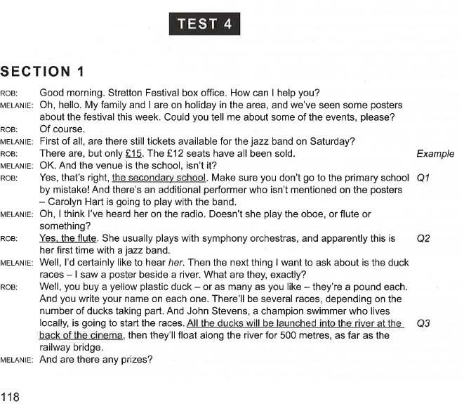

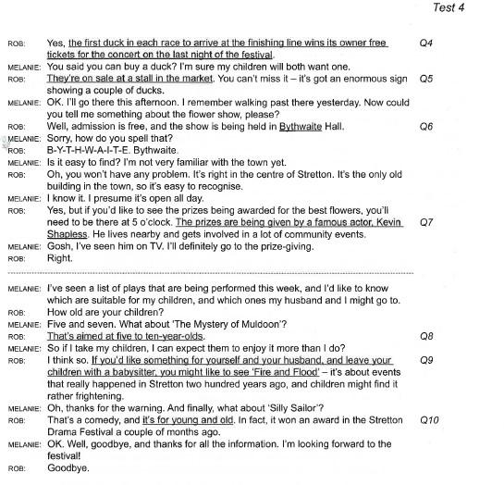
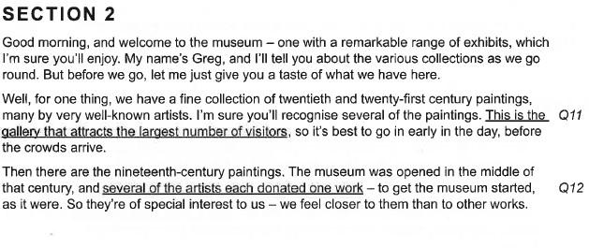

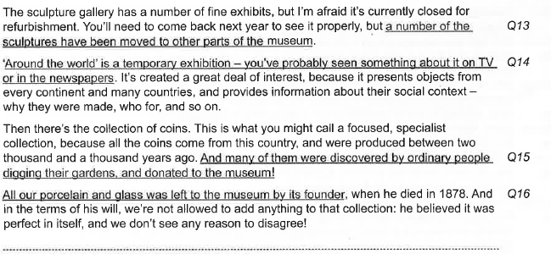
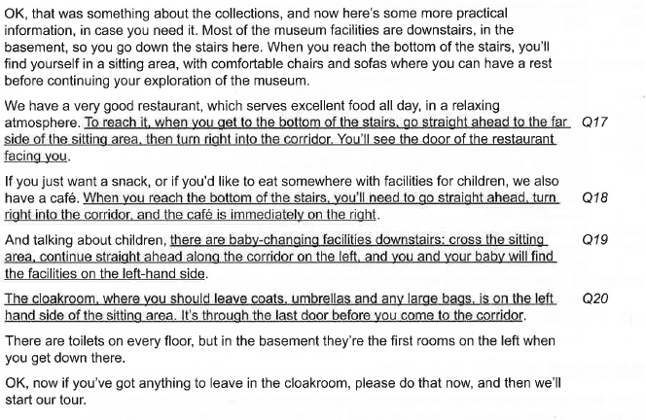

TEACHER RESOURCES AND ANSWER KEY
BASIC IELTS
LISTENING SESSION 4

Suggested answers

Note that none of these guarantee that is the answer in the exam!
- A is indeed - A
- A is still… - A
- A is supposed to… - Not A
- A still hasn’t… - Not A
- A used to be… - Not A
- A usually… - Not A
- A wise man once said A. - A
- A, and I would continue to… - A
- A, and that is the case. - A
- A, but… - Not A
- A, which is correct. - A
- A. I meant to say… - Not A
- A. Actually,… - Not A
- A. And I also… - A
- A. However,… - Not A
- A. I meant to say… - Not A
- A. I was mistaken,… - Not A
- A. In reality,… - Not A
- A. My mistake,… - Not A
- A. Silly me!... – Not A
- A. Sorry,… - Not A
- A. Whoops… - Not A
- Again, A. - A
- Although A,… - Not A
- As expected, A. - A
- As I said earlier, A. - A
- As most people think, A. - A
- As the proverb goes, A. - A
- As usual, A. - A
- At first, A… - Not A
- Despite A,… - Not A
- Despite the doubts about A,… - A
- Due to the weather, A… - Not A
- He claims that it is A. – Not A
- I can see why you might think A. – Not A
- I think A, but just let me check. Yes, I was right. - A
- I thought A too, then… - Not A
- I’m afraid A… - Not A
- In spite of A,… - Not A
- Instead of A,… - Not A
- It is commonly thought that A. – Not A
- It is well known that A. - A
- Many people have heard that A, and that is indeed so. - A
- Most people think A. – Not A
- My initial impression was A. – Not A

- My philosophy on this is A. - A
- Rather than A,… - Not A
- Sorry but A… - Not A
- The consensus is A. – A
- The plan was A. – Not A
- The two options are A and B. The former… - A
- The two possibilities are A and B. The latter… - Not A
- There is a consensus on A. - A
- To start with A,… - Not A
- Unfortunately, A... – Not A
- Unlike A,… - Not A
- We are going to A. – A
- We are planning to A. – A
- We intend to A. – A
- We settled on A. – A
- We were going to A. – Not A
- We were intending to A. – Not A
- We were planning to A. – Not A
- You could A. – Not A
- You might think that A. – Not A
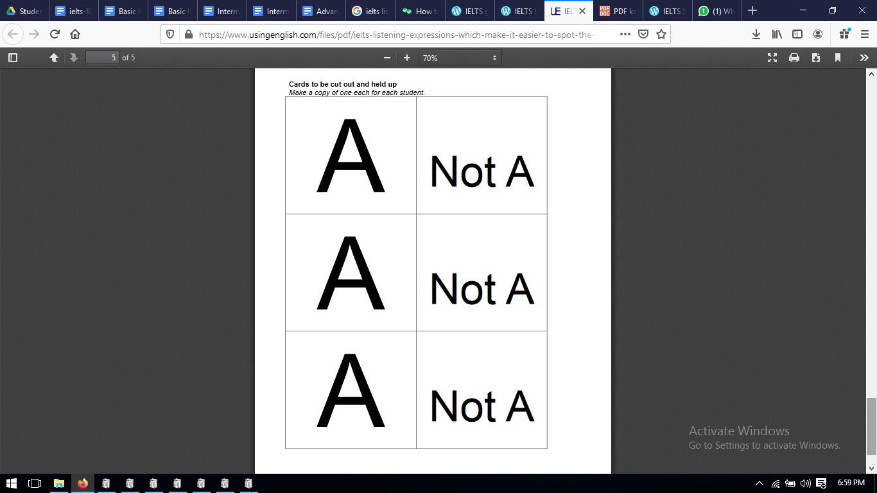

TEACHER RESOURCES AND ANSWER KEY
BASIC IELTS
READING SESSION 5

IELTS Academic Reading Task Type 2 (Identifying Information) and Type 3 (Identifying Writer’s Views/Claims) Activity – answer keys

Key to Worksheet 1 Exercises 1, 2 and 3 – Step 2 (key words)
Key words in bold:
- Thirty per cent of deaths in the United States are caused by smoking-related diseases.
- If one partner in a marriage smokes, the other is likely to take up smoking.
- Teenagers whose parents smoke are at risk of getting lung cancer at some time during their lives.
- Opponents of smoking financed the UCSF study.

Key to Worksheet 1 Exercises 1, 2 and 3 – Step 3 (paraphrase)
Alternative ways of expressing each statement: (many variations possible)
- Smoking is responsible for just under a third of all deaths in the US.
- If a husband or wife smokes, their spouse tends to start smoking too.
- Parents who smoke make their children breathe their smoke too, and this can cause lung cancer in their children later in life.
- The funding for the UCSF study came from people who are against smoking.

Key to Worksheet 1 Exercises 1, 2 and 3 – Step 4 (repeated words)
Key words found in both the statements and in the text shown in bold:
- Thirty per cent of deaths in the United States are caused by smoking-related diseases.
- If one partner in a marriage smokes, the other is likely to take up smoking.
- Teenagers whose parents smoke are at risk of getting lung cancer at some time during their lives.
- Opponents of smoking financed the UCSF study.

Key to Sample Task
- No – the text talks about percentages of deaths from cancer whereas in the statement it talks about deaths in general.
- Not given – the text talks about the effects on the partner of passive smoking but doesn’t mention if the partners tend to start smoking themselves.
- Yes – the text states that lung cancer can be attributed to high levels of exposure to second-hand tobacco smoke during childhood and adolescence – in other words, children and teenagers breathing their parents’ smoke.
- Not given – the text states that the American Medical Association is an opponent of smoking but doesn’t say whether UCSF is or not.

TEACHER RESOURCES AND ANSWER KEY
BASIC IELTS
READING SESSION 6

IELTS Academic Reading Task Type 4 (Matching Information) Activity – answer keys

Key to Exercise 1
- The text has a title which gives the main topic of the text. True – The Motor Car, this is what the text is about in general.

- There are illustrations with this text which help you understand parts of the text. False – but in some texts there might be and this would help you understand the text.

- There are more paragraphs than questions.
True – there are 8 paragraphs and only 6 questions so not every paragraph will be used.

- You can use a paragraph more than once.
True – one paragraph could contain information on more than one question so always skim read through all the questions each time.

- The task is the same as Task Type 5 Matching Headings.
False – this task is about locating specific information whereas Task Type 5 was matching sentences containing the main idea of a paragraph.

Key to Exercise 2

A comparison of past and present transportation methods | changes in the types of transport over time
how driving habits contribute to road problems | the way in which people drive makes road problems worse
the relative merits of cars and public transport | the advantages of both trains and car
the writer’s prediction on future solutions | how the author thinks transport problems will be solved
the increasing use of motor vehicles | the growth in the amount of kilometres driven by car
the impact of the car on city development | how the car has influenced the features of cities

Key to Exercise 3

The best technique is to read the first paragraph and then look through the information points to see if one of them can be found in the first paragraph.
Agree – because you are looking for specific information, it is easier to read a paragraph and then look through the information points to see if the paragraph contained any of them.

It is a good idea to re-read the same paragraph several times to make sure of your answer before moving on to the next paragraph.
Disagree – you will waste time if you do this as some paragraphs do not contain an information point. It is better to continue and then check your answers at the end

If the exact same words appear in the text as in an information point, then this must be the correct paragraph.
Disagree – more than one paragraph may deal with the same general area as an information point so the words may appear in more than one paragraph. You need to look for the information not the words

If you cannot find an information point for a paragraph quickly, then you should move on and come back to it again later.
Agree – some paragraphs do not contain an information point so don’t spend too long on any one paragraph.

Every time you have read a paragraph, you must look at all information points again, even those that you think you have matched.
Agree – you should read through them quickly again to check that you haven’t made any mistakes and keep an open mind about your answers until you have read all the paragraphs. This will also help you ‘learn’ the information points so by the end you know what kind of information you are looking out for in the text.

Key to Sample Task
- C
- F
- E
- H
- A
- D

TEACHER RESOURCES AND ANSWER KEY
BASIC IELTS
READING SESSION 7

IELTS Academic Reading Task Type 5 (Matching Headings) Activity – answer keys

Key to Classroom Activity
- A heading is a short sentence or expression which explains the most important point in a text
- The main point of a paragraph is usually found in the topic sentence, which may be the first or last sentence of the paragraph, or less commonly, in the middle.
- Spend a minute or so getting the main idea about the text as a whole by skimming it and looking at any titles, sub-titles and illustrations there are.

Key to Sample Task
- v
- vii
- ii
- iv
- i

TEACHER RESOURCES AND ANSWER KEY
BASIC IELTS
WRITING SESSION 8

Completed model text (suggested answers)

Salmon begin life as eggs on a pebbly riverbed, hidden among reeds in the slow‐moving upper reaches of a river. After five to six months the eggs hatch into 'fry'. For approximately the next four years, these baby salmon will live in the lower, faster‐flowing waters of their river. During this time they measure between three and eight centimetres in length.
By the time/After the salmon reach twelve to fifteen centimetres, they are termed 'smolt', and at this time they migrate further downriver into the open sea. After five years at sea the salmon will have grown to adult size, which is between seventy and seventy‐six centimetres. They then begin swimming back to their birthplace, where they will lay their eggs, and the cycle starts anew.
In summary, the salmon passes through three distinct physical stages as it grows to maturity. Each of these stages takes place in a very different aquatic location. It is noteworthy that the first two stages of this fish's life occur in a freshwater environment, while the third stage is lived in saltwater.

